Integrated Flood and Landslide Risk Assessment and Response System for Sri Lanka

Emergency Response and Resource Coordination

Project ID : J26-IT-334

Project Proposal Report
Palihena M B – IT23411562

B.Sc. (Hons) Degree in Information Technology Specialized in
Information Technology

Department of Information Technology
Sri Lanka Institute of Information Technology Sri Lanka

September 2026

DECLARATION
I declare that this is my own work, and this proposal does not knowingly incorporate any material previously submitted for a degree or diploma at any other university or higher education institution, nor does it contain any material that has been previously published or written by another person apart from where proper acknowledgment is given in the text.

Name | Student ID | Signature
Palihena M B | IT23411562 | 

The above candidate is conducting research for their undergraduate Dissertation under my supervision.
Name | Date | Signature

ABSTRACT
Sri Lanka has two monsoon seasons every year. These seasons often bring rain that causes floods and landslides, particularly in the central highlands and low-lying river basins. These disasters lead to loss of life, people being displaced from their homes, and damage to roads, bridges, and buildings. Cyclone Ditwah in late 2025 alone caused 646 fatalities and affected approximately 2.2 million people across all 25 districts, exposing critical weaknesses in how resources are coordinated once a hazard has already been identified. Even when early-warning systems correctly flag high-risk areas, Sri Lanka's disaster response still relies mostly on manual phone and radio coordination between District Disaster Management Centers, with no shared visibility into which ambulances, boats, or shelters are available at the time of an event. Previous studies show that in comparable disaster contexts, this lack of a shared resource registry results in a large share of dispatch effort being duplicated to areas already served, while systems with live availability checks substantially reduce this waste. Existing routing tools used in this context also rely on third-party mapping services that cannot account for locally derived flood or landslide hazard data, meaning routes cannot be automatically adjusted when a specific road becomes unsafe.
Manual coordination leaves no shared record of what has already been dispatched, and existing routing tools cannot adjust for hazards they were never designed to see. This leaves a gap between identifying a hazard and safely, efficiently acting on it. To close this gap, this paper introduces a component called the Emergency Response and Resource Coordination module. This module is part of a system called the Integrated Flood and Landslide Risk Assessment and Response System for Sri Lanka. The new module uses data like ambulance and shelter inventories, relief stock levels, road network data, and historical disaster response records. It checks real-time resource availability, sequences multiple affected districts by priority when resources are limited, and uses a constraint-based optimization solver to allocate available resources under capacity constraints. It also generates hazard-aware routes for both citizen evacuation and rescue-team dispatch by dynamically excluding road segments affected by flooding or landslide activity.
The design also includes multi-channel dispatch that delivers resource, route, and shelter information to DMC coordinators and citizens via SMS and application notifications in Sinhala, Tamil, and English. It also includes a closed-loop feedback layer using a machine-learning model trained on historical response outcomes, which helps improve future allocation efficiency over successive disaster events.
Keywords - resource allocation, hazard-aware routing, disaster response coordination, constraint-based optimization, disaster risk reduction

ACKNOWLEDGEMENT
I would like to express my gratitude to everyone who supported me throughout the course of this research project.
First and foremost, I extend my appreciation to my supervisor and co-supervisor for their invaluable guidance, constructive feedback and continuous encouragement throughout the development of this project. Their expertise and insightful direction were instrumental in shaping the scope, methodology and overall quality of this work.
I would also like to thank the Topic Screening Panel for their review and constructive comments during the topic assessment stage, which helped refine the direction of this research.
My sincere thanks go to the officials at the Disaster Management Centre (DMC) for their guidance in facilitating the data request process and for sharing their knowledge, which greatly informed the requirements and data-acquisition strategy for this component.
I am also grateful to the National Building Research Organization (NBRO) and the Department of Meteorology, Sri Lanka for maintaining and providing access to the landslide and rainfall data resources that form the foundation of this research.
I would like to thank my team members for their collaboration, shared effort and coordination in developing the integrated components of this project and, for the collective work that made the overall system possible.
Finally, I would like to thank my family and friends for their support, patience and encouragement throughout the duration of this project.
TABLE OF CONTENT
ACKNOWLEDGEMENT 4
LIST OF TABLES 7
LIST OF FIGURES 8
LIST OF ABBREVIATIONS 9
LIST OF APPENDICES 10
1. INTRODUCTION 11
1.1 Background and Context 11
The real world problem 11
Who is affected, and why it matters. 11
Statistical evidence. 11
Analysis of existing solutions and their limitations. 11
Proposed solution and its parts. 13
SDG alignment. 13
Research cluster alignment. 13
1.2 Literature Review 14
Part A: Peer-Reviewed Literature 14
A.1 Gaidzik & Ramírez-Herrera (2021) -"The Importance of Input Data on Landslide Susceptibility Mapping" 14
A.2 Brenning (2005) - "Spatial Prediction Models for Landslide Hazards: Review, Comparison and Evaluation" 15
A.3 Gunasinghe, Gunawardhana & Rajapakse (2023) - "Predictive Analysis of Landslide Susceptibility under Hydrological Aspects of Climate Change in Kegalle District, Sri Lanka" 16
Part B :Existing Systems and Products 17
B.1 ResQConnect (Aththanayake et al., 2026) 17
B.2 NBRO/DMC Operational Early-Warning System 17
B.3 Walapane AHP Landslide Hazard Zonation Study (2018) 18
1.3 Research Gap 19
Feature 1- No comparative, locally calibrated probabilistic forecasting engine. 19
Feature 2- No continuously updated, accessible severity output at the community level. 19
Feature 3- No factor-level explanation of individual predictions. 20
2. OBJECTIVE 21
2.1 Main Objective 21
2.2 Specific Objectives 21
To acquire and compile the core landslide dataset 21
To construct a multi-factor geospatial feature set 21
To integrate human-factor risk parameters 21
To train and comparatively evaluate machine-learning classification models 21
To develop a WebGL-powered, dual-language (Sinhala/Tamil/English) live mapping interface 21
To implement an explainable-AI layer 21
3. METHODOLOGY 22
3.1 Research Methodology / Design 22
3.2 Data / Experimental Inputs 22
3.3 Baseline / Benchmark 24
3.4 Evaluation Metrics 24
3.5 Validation Strategy 25
3.6 Development Approach 25
4.HIGH-LEVEL SYSTEM ARCHITECTURE 26
4.1 Overview of Proposed Solution and its Components 26
4.3 Individual Component 28
4.4 Overall Integration 29
4.5 Individual Responsibility Boundary 30
5.USER REQUIREMENTS 31
5.1 Evidence-Gathering Activities 31
5.2 Translated System Requirements 31
Functional Requirements 31
Non-Functional Requirements 32
6. COMMERCIALIZATION PLAN 33
6.1 Target Market and Customer Persona 33
6.2 Value Proposition 33
6.3 Revenue Model 33
6.4 Cost Estimation 34
6.5 Pricing Strategy 34
6.6 Competitive Advantage 34
6.7 Intellectual Property Considerations 35
7.BUDGET AND JUSTIFICATION 36
7.1 Hardware Costs 36
7.2 Software Licenses 36
7.3 Cloud Services 37
7.4 Summary Justification 37
8. WORK BREAKDOWN STRUCTURE (WBS) 38
9. GANTT CHART 39
10. APPENDICES 42
Appendix 2 - Mandatory Proposal Evidence and Decision Log 46
Appendix 3 - AI Use Disclosure 46

LIST OF TABLES

LIST OF TABLES 6
3.4 Evaluation Metrics 23
4.5 Individual Responsibility Boundary 29
7.1 Hardware Costs 35
7.2 Software Licenses 35
7.3 Cloud Services 36
Appendix 2 - Mandatory Proposal Evidence and Decision Log 45
Appendix 3 - AI Use Disclosure 45

LIST OF FIGURES

Figure 1. Landslide incident distribution in Nuwara Eliya District following Cyclone Ditwah, showing 22 recorded incidents concentrated around Walapane and Kotmale — the study area's most exposed divisions. Source: [dashboard publisher] 12
Figure 2.Tools and Software That We Going to Use to Implement Our Research Components 22
Figure 3.architecture diagram, black-and-white, own component highlighted 26
Figure 4.System Architecture Diagram Integrated Flood and Landslide Risk Assessment and Response System for Sri Lanka 27
Figure 5.Work Break Down Chart For Whole System 37
Figure 6.Gaant Chart Of my Component 38

LIST OF ABBREVIATIONS

Abbreviation | Full Form
AI | Artificial Intelligence
AHP | Analytical Hierarchical Process
API | Application Programming Interface
AUC | Area Under the Curve
B2G | Business to Government
DEM | Digital Elevation Model
DMC | Disaster Management Center
GIS | Geographical Information system
GPU | Graphic Use Interface
PostGIS | Spatial Database Extender for PostgreSQL
SDG | Sustainable Development Goal
WBS | Work Breakdown Structure
SVM | Support Vector Machine
SaaS | Software As a Service
OSM | Open Street Map
NBRO | National Building Research Organization
NBRI | National Building Research Institute
LHMP | Landslide Hazard Mapping Project
DDMC | Data Domain Management Center

LIST OF APPENDICES
LIST OF APPENDICES 10
Appendix 1 42
Appendix B: Prototype Evidence - Individual Component (Landslide Prediction) 44
Appendix C: Preliminary Research Notes (Requirements Elicitation & Research Design) 45
Appendix 2 - Mandatory Proposal Evidence and Decision Log 46
Appendix 3 - AI Use Disclosure 46

INTRODUCTION

Background and Context
The real-world problem. When a flood or landslide alert is issued in Sri Lanka, the response that follows is still largely manual phone calls and radio coordination between District Disaster Management Centers (DDMCs), no shared visibility into which ambulances, boats, or shelters are actually available, and no systematic way to route rescue teams or evacuees around roads that are already flooded or blocked. Decision-makers currently receive what is at risk from early-warning systems but have no automated way to convert that into who gets dispatched, by which route, and how quickly.
Who is affected, and why it matters. The people most affected are twofold: DDMC officers and Incident Commanders, who must allocate scarce resources across multiple affected districts under time pressure with no live inventory system; and citizens in flood- and landslide-prone districts, whose safety depends on how quickly a rescue team or evacuation order reaches them once a hazard is confirmed. Delays or misallocation at this stage directly translate into avoidable casualties and duplicated relief efforts.

Statistical evidence.
Cyclone Ditwah (late 2025) caused 646 fatalities, left 173 people missing, and affected approximately 2.2 million people across all 25 districts of Sri Lanka, with displacement camps established in multiple districts simultaneously [1]. a scale that requires coordinated, multi-district resource allocation rather than single-location manual dispatch. Earlier, the 2017 floods and earth slips affected 557,505 people across 151,392 families in 15 districts [2], demonstrating that simultaneous multi-district disasters are a recurring, not exceptional, pattern in Sri Lanka. Comparable international evidence reinforces the coordination risk: a 2026 Indian disaster-response study documented that manual, registry-less dispatch resulted in 23% of resource assignments being duplicated to zones already served, while a shared digital resource registry reduced this to 4% [3]. It indicates this is a general coordination failure mode, not one unique to Sri Lanka.
Analysis of existing solutions and their limitations.
Current approaches fall into four categories:
(1) Manual/ad hoc coordination via phone and radio, which is reactive and has no shared resource visibility [4].
(2) Single-purpose donation/relief-matching applications such as Donate.lk, which route a single team via a third-party maps API but never verify live resource availability before dispatch [4].
(3) AI-driven allocation and communication platforms built for other countries, such as India's DREMS, which optimize dispatch and routing but at a broader, district-level accessibility score rather than road-segment-level hazard exclusion and are structured around a different national agency framework [3].
(4) Agentic, citizen-facing response-coordination systems such as ResQConnect, which is the closest Sri Lankan precedent but is purely reactive, it plans tasks and routes only after a citizen has already reported an incident, with no live resource-availability check beforehand [5]. None combines live resource verification, hazard-aware routing at the road-segment level and closed-loop learning in one system calibrated for Sri Lanka's DDMC structure.
Proposed solution and its parts. This component, Emergency Response and Resource Coordination, addresses this through three integrated parts: (1) a real-time, resource-aware allocation engine that checks live DDMC inventory (ambulances, boats, shelters, relief stock) and assigns resources to prioritized districts under capacity constraints using operations-research optimization; (2) a hazard-aware dual route optimizer that dynamically excludes flood- and landslide-blocked road segments for both citizen evacuation and rescue-team dispatch; and (3) a multi-channel dispatch mechanism with a closed-loop feedback model that logs actual response outcomes to improve future allocation decisions.
SDG alignment. This component aligns primarily with SDG 11 (Sustainable Cities and Communities), Target 11.5, which calls for significantly reducing deaths and economic losses from disasters, and SDG 9 (Industry, Innovation and Infrastructure) through resilient, technology-enabled logistics and dispatch infrastructure. It contributes indirectly to SDG 13 (Climate Action), Target 13.1, by strengthening adaptive response capacity to climate-related hazards.
Research cluster alignment. This component aligns with SLIIT's Center of Excellence for AI (CEAI). Its core contribution is constraint-based optimization for real-time resource allocation, paired with a machine-learning feedback layer that improves future dispatch decisions from historical outcomes which reflects CEAI's focus on applied AI systems that produce measurable, real-world operational impact rather than purely theoretical modelling.

Literature Review

Part A: Peer-Reviewed Literature

A.1 Barbarosoglu & Arda (2004) - "A two-stage stochastic programming framework for transportation planning in disaster response"
- Method: A two-stage stochastic programming formulation for humanitarian logistics under demand and supply uncertainty.
- Dataset: Illustrated using a large-scale earthquake disaster-response case in Turkey, with demand/supply scenarios generated to represent uncertain post-disaster conditions rather than a single fixed historical dataset.
- Context: Earthquake logistics planning in a seismically active region a different hazard type and geography from Sri Lanka's flood/landslide context, but structurally the same resource-allocation-under-uncertainty problem.
- Findings: Demonstrates that treating relief dispatch as a formal constrained-optimization problem, rather than manual judgment, produces measurably better allocation outcomes under uncertainty.
- Strengths: Establishes the theoretical basis for using optimization solvers (rather than heuristics or manual rules) for resource allocation under scarcity.
- Limitations relative to this research: A generalized theoretical formulation with no real-time component, no hazard-aware routing, and no Sri Lanka-specific calibration.
- Influence on proposed research: Justifies the use of a constraint-based optimization solver (OR-Tools) over rule-based or manual allocation logic in this component's allocation engine.

A.2 Balcik & Beamon (2008) -"Facility location in humanitarian relief"
- Method: Facility-location and allocation modelling for relief supply chains, emphasizing pre-positioning of critical relief materials near high-risk zones.
- Dataset: A generalized facility-location and inventory-allocation model illustrated conceptually rather than validated against one specific disaster event dataset.
- Context: General humanitarian relief supply-chain design, not tied to a specific country or hazard type.
- Findings: Pre-positioned, registry-tracked resources significantly outperform ad hoc, on-demand sourcing during active disaster response.
- Strengths: Directly supports the design decision to maintain a live, query-based resource registry rather than relying on manual, per-event resource sourcing.
- Limitations relative to this research: Focused on facility placement and supply-chain design rather than real-time dispatch optimization or road-network routing; not validated in a Sri Lankan or DDMC operational context.
- Influence on proposed research: Reinforces the design of a centralized, real-time resource inventory (PostGIS-backed) as a precondition for effective allocation, consistent with this component's Resource-Aware Dispatch feature.

A.3 Reina et al. (2014) - "The role of ad hoc networks in disaster response: A survey"
- Method: Survey and field evaluation of ad hoc and mesh communication networks operating under cellular-blackout disaster conditions.
- Dataset: A literature survey - synthesizes findings across multiple published ad hoc/mesh networking field studies rather than presenting a single primary dataset.
- Context: Disaster communication infrastructure broadly, across multiple hazard types and geographies, not Sri Lanka-specific.
- Findings: Low-bandwidth mesh/ad hoc communication reliably maintains command-and-coordination messaging even when standard cellular infrastructure fails, with practical node-to-node ranges of 5-10 km in rural terrain.
- Strengths: Provides evidence that dispatch communication must not depend solely on standard cellular/SMS channels during major disasters.
- Limitations relative to this research: A communications-infrastructure study, not a resource-allocation or routing study; does not address dispatch decision logic.
- Influence on proposed research: Informs this component's Multi-Channel Dispatch feature - while the primary channel is SMS/app-based, the design acknowledges cellular-blackout risk as a factor future iteration should account for.

Part B: Existing Systems and Products

B.1 Donate.lk (Lanerolle et al., 2018)
- Functions: Mobile/web system matching donated relief items to victim requests and routing a single donation team using a third-party maps API.
- Technology: Google Maps API for routing; rule-based, non-optimization item-matching logic.
- Performance: Reported functional testing only (initialization time ~12 seconds, 3-4 second API response latency); no quantitative accuracy, efficiency, or response-time improvement metrics were published against a manual baseline.
- Users: Donation-team administrators and field volunteers (web/mobile app), and victims submitting relief requests (mobile app).
- Limitations relative to this component: No live resource-availability check before dispatch; single-team routing only, with no ability to exclude specific hazard-blocked road segments since routing is delegated to a third-party black-box API.

B.2 DREMS (Muralidharan et al., 2026)
- Functions: Six-module Indian disaster-response platform including a priority-weighted resource allocation optimizer and LoRa mesh communication.
- Technology: Greedy heuristic with 2-opt improvement for allocation; accessibility treated as one scoring factor within district-level priority, not a road-segment-level routing constraint.
- Performance: Reported a 34.5% reduction in first-response time and an 82.6% reduction in duplicate resource assignments versus manual dispatch.
- Users: NDRF/SDRF field teams, district Incident Commanders, and NDMA-level command dashboards.
- Limitations relative to this component: Built around India's NDRF/SDRF agency structure, not Sri Lanka's DDMC system; routing operates at coarser district-accessibility granularity rather than dynamically excluding specific blocked road segments.

B.3 ResQConnect (Aththanayake et al., 2026)
- Functions: Agentic RAG pipeline converting citizen-reported incidents into task plans, with an event-triggered vehicle-routing engine and an offline mobile guidance model.
- Technology: Multi-agent LLM architecture (GPT-4o) with a quantized on-device model for offline use.
- Performance: Improved task-quality scores from 61.4 to 82.9 over a standard RAG baseline; reduced routing solver calls by up to 85% while remaining within 7–12% of optimal response time; delivered offline mobile guidance at sub-500 ms latency.
- Users: Disaster-management agencies and field responders (task plans, routing outputs) and affected citizens.
- Limitations relative to this component: Purely reactive - It operates only after a citizen has already reported an incident, with no live resource-availability verification and no explicit hazard-based road exclusion.

B.4 Current Manual DDMC Coordination (status quo baseline)
- Functions: Phone-and radio-based coordination between district officers.
- Limitations relative to this component: No shared resource visibility, no optimization, and no systematic hazard-aware routing - the direct baseline this component aims to improve upon.

Research Gap
Across manual coordination, single-purpose relief-matching apps, internationally built allocation platforms, and agentic response-coordination systems, no existing solution combines live, DDMC-level resource-availability checking, road-segment-level hazard-aware dual routing, and closed-loop, outcome-based learning in a system built for Sri Lanka's disaster-management structure. This proposed component is structured around three integrated features specifically because each closes a distinct, evidenced gap left open by the systems already discussed.
Feature 1- No real-time, resource-verified dispatch for Sri Lanka's DDMC network.
Donate.lk and ResQConnect both proceed to routing and coordination without confirming a specific resource is available beforehand [4], [5]. DREMS maintains a registry but treats availability as one scoring factor among several rather than a hard precondition and is built around India's NDRF/SDRF structure with no Sri Lankan equivalent [3]. The cost of this gap is measurable: manual dispatch without a shared registry produced 23% duplicate resource assignments, dropping to 4% once one was introduced [3]. No system verifies live DDMC-specific resource availability as a precondition for dispatch in the Sri Lankan context - the gap this component's Real-Time Resource-Aware Dispatch feature addresses.
Feature 2- No dynamic, road-segment-level hazard-aware routing for both evacuation and rescue dispatch simultaneously.
Donate.lk delegates routing entirely to Google Maps API, which cannot accept custom hazard-blocked segments [4]. DREMS treats road accessibility as one weighted factor in a district-level score rather than a live routing constraint, so a district can be marked reachable even if the specific access road is blocked [3]. ResQConnect optimizes multi-commodity delivery routes but does not exclude hazard-blocked segments dynamically or route for both evacuation and rescue purposes at once [5]. No system dynamically updates a road network at the segment level using live hazard data for dual-purpose routing - the gap this component's Hazard-Aware Dual Route Optimization feature closes.
Feature 3- No closed-loop allocation model calibrated to Sri Lankan disaster-response outcomes.
Manual coordination logs no outcomes at all. DREMS evaluates allocation performance only as a one-time simulation benchmark, with no mechanism to retrain on new outcomes [3]. ResQConnect's efficiency gains come from caching or storing prior routing solutions, not from learning which allocation strategies produced better real-world results [5]. Whether a feedback model trained on Sri Lanka-specific response data can measurably improve allocation efficiency over successive events remains unanswered - the question this component's Closed-Loop Response Feedback feature investigates.

OBJECTIVE

2.1 Main Objective
To develop a real-time emergency response and resource coordination system that translates prioritized district-level alerts into operational resource allocation, optimized routing, and dispatch actions for Sri Lanka's disaster management authorities.

2.2 Specific Objectives
To ingest prioritized district-level alerts and verify real-time resource availability (ambulances, boats, shelters, relief stock) via a standardized API before any dispatch decision is committed.
To design a scarcity-based priority queuing model that sequences resource allocation across multiple simultaneously affected districts.
To develop a constraint-based resource allocation engine, using operations-research optimization, that assigns available resources to affected districts under capacity and resource-type-matching constraints.
To construct a hazard-aware dual route optimization module that dynamically excludes flood- and landslide-blocked road segments for both citizen evacuation and rescue-team dispatch.
To implement a multi-channel dispatch mechanism that delivers localized alerts and resource/route information to DMC coordinators and citizens.
To build a closed-loop feedback model that logs actual response outcomes and improves future allocation efficiency using historical and simulated Sri Lankan disaster data.

3. METHODOLOGY

3.1 Research Methodology / Design
Nature of the research question: The core question - "can an optimization-based, hazard-aware coordination system allocate and dispatch resources more efficiently than manual or heuristic dispatch for Sri Lanka's DDMC structure?"- is comparative and quantifiable, with measurable outcomes (response time, resource utilization, duplicate assignments, district coverage). It is not exploratory or interpretive; it requires numeric, testable answers benchmarked against a defined baseline.
Type of data: All inputs are structured, numeric or categorical operational and geospatial data resource counts and station coordinates, shelter capacities, road-network graph edges, district population figures, and historical event-level response records. This is the data shape that constrained-optimization and supervised-learning methods are designed for.
Experimental requirements: Comparing the proposed allocation and routing engine against a manual/heuristic baseline requires a controlled, repeatable experimental setup: identical disaster scenarios run through both approaches, with consistent metrics measured across runs. This rules out purely qualitative or case-study designs.
Relevant literature: Barbarosoglu and Arda [6] and Balcik and Beamon [7] both formulate disaster resource allocation as a quantitative optimization problem evaluated against defined objective functions, and DREMS [3] evaluates its allocator by comparing simulated performance against a documented manual baseline. This proposal follows the same established convention.
Selected methodology: A quantitative, experimental (comparative) research design, structured as a simulation-based evaluation pipeline: data acquisition → resource and road-network modelling → allocation/routing implementation → scenario-based comparative evaluation → validation against historical event records.

3.2 Data / Experimental Inputs
This component involves no human participants; it is an operational and geospatial modelling task using secondary administrative data. (If the dispatch interface undergoes later usability testing with DMC officers, that would introduce a small participant-based sub-study.)
- Data sources: Ambulance fleet counts and station locations, Shelter/safety-center locations and capacity, District/divisional administrative boundaries, Relief stock / NFI availability patterns, Full Road graph (routing engine), Road classification (optional), Road/bridge damage counts by district, Flood-blocked road segments, District/GN-division population and age structure, Gridded population, Event-level disaster records (fatalities, displaced, duration), Named-event situation/PDNA reports
- Dataset composition:
- 1990 Suwa Seriya (297 ambulances, published district breakdown), DMC situation reports and PDNA reports; ReliefWeb Sri Lanka, DMC DDMCU structure, DMC Rapid Needs Assessment reports (e.g., 2025 Ditwah PDNA)
- OpenStreetMap Sri Lanka extract via Geofabrik, Road Development Authority (RDA) Sri Lanka, DMC situation reports (per-event), Derived: intersecting Component 1 flood-extent polygons with the OSM road graph
- Department of Census and Statistics, Sri Lanka, WorldPop
- DesInventar Sri Lanka, DMC / ReliefWeb
- Study area / sample: Multi-district scope covering historically high-exposure districts (e.g., Ratnapura, Kegalle, Kalutara, Nuwara Eliya, Colombo), since the scarcity-based queuing feature only becomes meaningful when several districts are affected simultaneously.
- Collection method: Formal institutional data-sharing requests to DMC (already in progress as a team-level request covering the landslide, decision-support, and emergency-response components), supplemented by open geospatial sources (OpenStreetMap/Geofabrik, WorldPop) and public disaster repositories (DesInventar, ReliefWeb).
- Preparation process: Geospatial preprocessing (QGIS/PostGIS) will align all layers to a common coordinate reference system, geocode resource station and shelter locations as spatial points, and build a routable road graph using OSMnx/NetworkX. Hazard-blocked segments will be derived by spatially intersecting upstream flood/landslide polygons with road edges. Historical event records will be structured into response-outcome training samples for the feedback model; where real dispatch logs are unavailable, synthetic dispatch outcomes will be generated by replaying historical events through the allocation engine.




















Figure 2.Tools and Software That We Are Going to Use to Implement Our Research Components

3.3 Baseline / Benchmark

- Manual dispatch baseline - the current DDMC phone/radio coordination practice, modelled as first-available/nearest-unit assignment with no shared registry and no hazard-aware routing. This is the primary comparison, since it represents what the component would replace.
- Greedy heuristic allocation benchmark - DREMS's greedy + 2-opt optimizer [3], reported to achieve a 34.5% reduction in first-response time and an 82.6% reduction in duplicate assignments against its manual baseline, providing an external reference for what "good" allocation improvement looks like.
- Hazard-unaware routing benchmark - standard shortest-path routing on the unmodified road graph, used to isolate the specific contribution of hazard-aware segment exclusion.

3.4 Evaluation Metrics
Comparison | Why Relevant | Target/Comparison
Mean first-response time | The primary operational outcome; directly reflects how quickly help reaches an affected district | ≥ 30% reduction vs. manual baseline (comparable to the 34.5% reported in [3])
Duplicate resource assignment rate | Measures whether live availability checking prevents committing already-deployed assets - the core claim of Feature 1 | ≤ 5% (vs. 23% manual baseline in [3]
District coverage under scarcity | Tests whether priority queuing serves the most urgent districts first when supply is constrained | ≥ 75% of alerted districts served within the first response window
Route safety / validity | Proportion of generated routes containing zero hazard-blocked segments; directly validates Feature 2 | 100% hazard-free routes where a feasible path exists
Route computation latency | Routes must be usable during an active event, not computed retrospectively | < 5 seconds per district route request
Allocation efficiency improvement (feedback model) | Tests whether closed-loop learning measurably improves allocation over successive events (Feature 3) | Measurable improvement across simulated iterations; MAE/RMSE reported for response-time prediction

3.5 Validation Strategy
Validation will use scenario-based simulation across multiple historical Sri Lankan disaster events (e.g., Cyclone Ditwah 2025, 2017 floods), replaying each event's documented district-level impact through both the proposed engine and the manual baseline under identical resource constraints, then comparing the metrics above.
Routing outputs will be validated against documented road/bridge damage records from DMC situation reports (e.g., 78 roads and 15 bridges damaged during Ditwah) to confirm that segments known to have been blocked are correctly excluded from generated routes.
For the feedback model, k-fold cross-validation will be applied to the response-outcome dataset, with a held-out event kept entirely outside training to test whether the model generalizes to an unseen disaster rather than only to cross-validated historical data.
Stated limitation: Since no live DDMC resource-status feed currently exists, real-time inventory will be simulated using published fleet and shelter figures with modelled status transitions. This is disclosed explicitly as a scope boundary, with live integration identified as future work.

3.6 Development Approach
Selected approach: An Agile, iterative prototyping approach, structured around short sprints.
Justification: This is appropriate for three reasons specific to this project:
- Staged data delivery - DMC/NBRO data is arriving incrementally through formal institutional requests, so the resource and road datasets cannot be finalized upfront; the design must be adapted as data arrives.
- Incremental, testable modules - each feature (ingestion → inventory → queuing → allocation → routing → dispatch → feedback) is independently demonstrable, making short increments a natural fit rather than one large late-stage delivery.
- Dependency on an upstream component - this component consumes Component 3's prioritized alert output, which is itself under active development. An API-contract-first, iterative approach allows this component to be built and tested against mock alerts before the upstream component is finalized.

4.HIGH-LEVEL SYSTEM ARCHITECTURE

4.1 Overview of Proposed Solution and its Components
The proposed system, Integrated Flood and Landslide Risk Assessment and Response System for Sri Lanka, is composed of four interdependent components that together transform raw environmental and citizen-generated data into coordinated disaster response actions for Sri Lanka. These are: (i) Flood Impact Assessment and Dynamic Mapping, which estimates flood severity and extent from hydrological and geospatial data; (ii) Landslide Prediction (this author's component), which computes site-specific landslide probability and identifies its causal factors; (iii) Multi-Hazard Early Warning Decision Support, which fuses hazard outputs from both prediction components into prioritized, actionable alerts; and (iv) Emergency Response and Resource Coordination, which converts alerts into dispatch and evacuation plans. The design follows a pipeline pattern comparable to recent human-centered disaster-response architectures, where specialized modules each handle one stage of the response chain and communicate through a shared, structured interface rather than a single monolithic model [ResQConnect].

4.2 System Diagram of Components
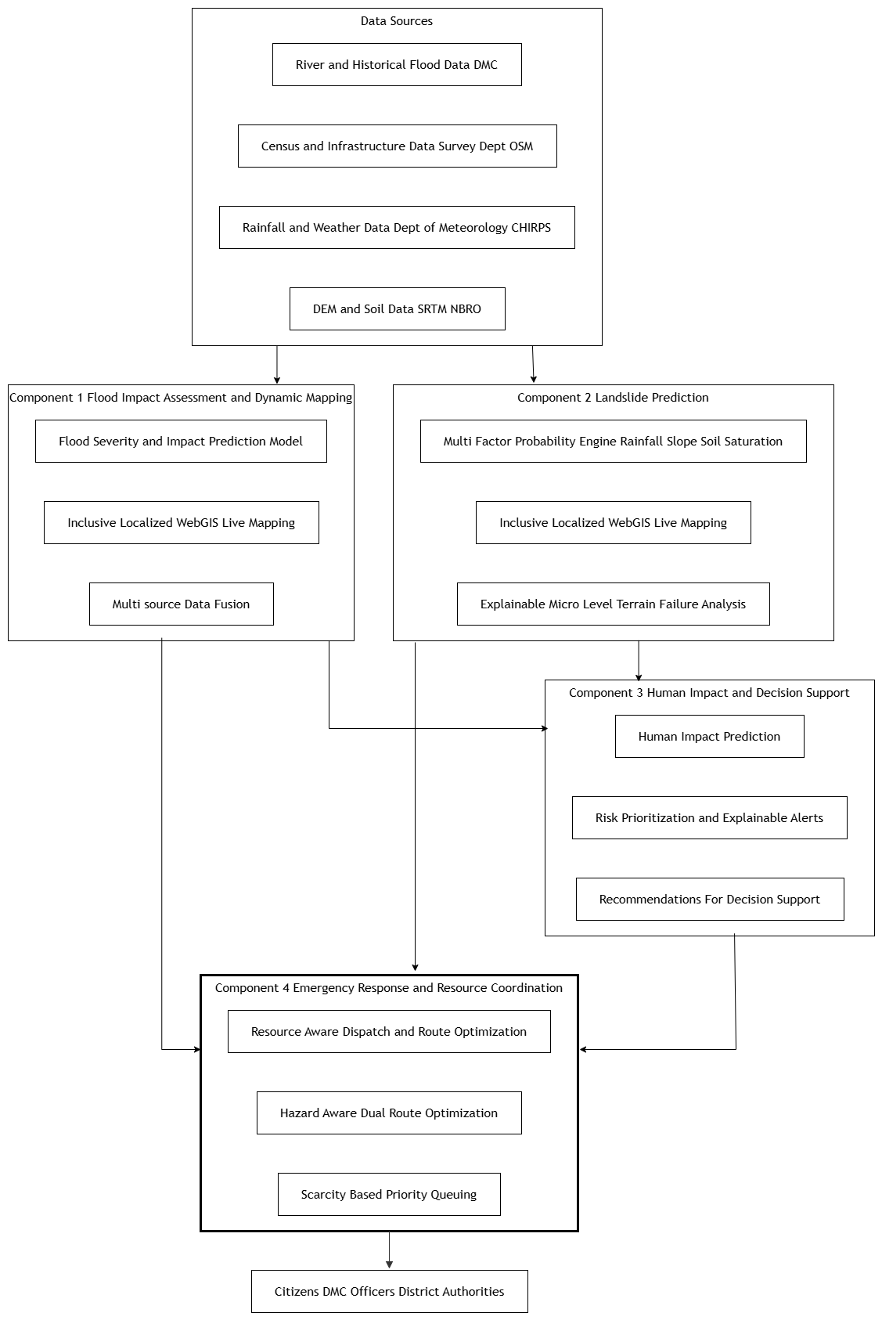

4.3 Individual Component
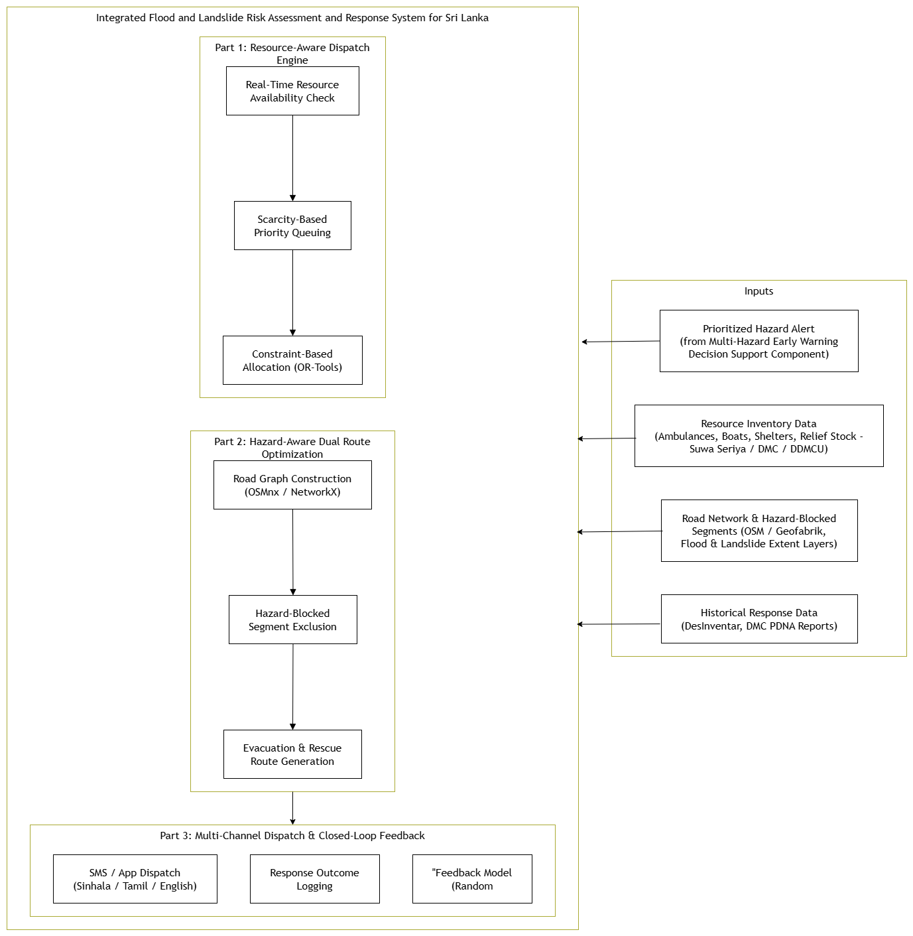
Figure 4.System Architecture Diagram Integrated Flood and Landslide Risk Assessment and Response System for Sri Lanka

4.4 Overall Integration
How the four components form a complete solution: Each component solves one link in the response chain, and none is independently sufficient the Flood and Landslide components only produce hazard likelihoods, the Decision Support component only prioritizes, and Emergency Response only acts. Only in sequence do they constitute an end-to-end early-warning-to-response system.
Dependencies: The Decision Support component has a hard input dependency on both the Landslide and Flood components' hazard outputs - it cannot compute a joint, multi-hazard risk score without both. Emergency Response, in turn, depends entirely on Decision Support's prioritized alert output; it does not consume raw hazard scores directly. The Landslide and Flood components are themselves independent of one another (no cross-dependency), which allows them to be developed, tested, and iterated in parallel.
Integration method: Components communicate through a standardized REST API contract, exchanging structured JSON records rather than sharing internal state, complemented by a common PostGIS spatial database for shared geospatial layers (road networks, administrative boundaries, resource locations). This integration approach was deliberately chosen so that this component can be developed and validated in isolation using mock alert payloads and simulated resource/road data before being plugged into the shared pipeline once the upstream alert schema is finalized.

4.5 Individual Responsibility Boundary

Activity / Deliverable | My Responsibility | Shared Responsibility | Other Member
Real-time resource inventory & availability-check engine | ✓
Scarcity-based district priority queuing | ✓
Constraint-based resource allocation (OR-Tools) | ✓
Hazard-aware dual route optimization (evacuation + rescue) | ✓
Multi-channel dispatch (SMS/app, DMC coordinators & citizens) | ✓
Closed-loop feedback model (response outcome logging & retraining) | ✓
Shared PostGIS spatial database schema and setup |  | ✓
Standardized alert-ingestion API contract |  | ✓
Flood severity & impact prediction model |  |  | Sinhalagoda S.A.U.R.A.V
Landslide probability & explainable-AI model |  |  | Bagya R M S
Joint hazard scoring & priority-based alert generation |  |  | Prathibhani Y.L.O.L

5.USER REQUIREMENTS

5.1 Evidence-Gathering Activities
Stakeholder discussions and domain-expert consultation: A formal data request letter was submitted to the Director General of the Disaster Management Centre (DMC), following guidance from Ms. Samanmali Matharaarachchi (Assistant Director, R&D), covering resource, road, and historical response data for the emergency-response component alongside the landslide and decision-support components. This engagement surfaced two institutional pain points directly relevant to this component: (i) resource and response data is fragmented across DMC, district-level DDMCs, and service providers with no unified real-time access point, and (ii) dispatch coordination during active events is conducted manually, with no shared record of what has already been deployed where.
Domain-expert/literature evidence: DREMS [3] documented that manual, registry-less dispatch produced a 23% duplicate resource assignment rate, falling to 4% once a shared registry was introduced - evidencing an institutional need for shared, real-time resource visibility rather than per-officer local knowledge. Balcik and Beamon [7] further established that registry-tracked, pre-positioned resources outperform ad hoc sourcing during active response, supporting a live inventory requirement rather than event-time resource discovery.
Existing-system review: Reviewing Donate.lk [4] and ResQConnect [5] showed that current Sri Lankan disaster-coordination tools proceed from request directly to routing without verifying resource availability, and that routing is either delegated to a third-party API or performed without dynamic hazard exclusion - motivating the availability-check and hazard-aware routing requirements below.

5.2 Translated System Requirements

Functional Requirements
- The system shall receive prioritized district-level alerts from the Decision Support component via a defined API contract, including hazard type, severity, affected divisions, and confidence.
- The system shall maintain and query a real-time inventory of response resources, ambulances, rescue boats, shelters (with capacity), and relief stock - at district level.
- The system shall verify live resource availability before committing any resource to a dispatch decision.
- The system shall sequence multiple simultaneously affected districts into a priority queue based on alert severity, population exposure, and vulnerability when resources are constrained.
- The system shall allocate available resources to prioritized districts subject to capacity, resource-type-matching, and proximity constraints.
- The system should generate optimized routes for both citizen evacuation and rescue-team dispatch, dynamically excluding road segments affected by flooding or landslide activity.
- The system shall dispatch resources, route, and shelter information to DMC coordinators and affected citizens via SMS and application notification, with localized message content.
- The system shall log response outcomes (arrival time, shelter occupancy, resource utilization) after each dispatch event.

Non-Functional Requirements
- Response time: The system shall return a complete allocation and routing plan for an alerted district within 5 seconds under normal network conditions.
- Reliability: The system shall generate a hazard-free route in 100% of cases where a feasible unblocked path exists and shall explicitly report infeasibility rather than returning an unsafe route.
- Scalability: The system shall process alerts for all 25 districts concurrently without degradation beyond the 5-second threshold above.
- Usability: A DMC officer unfamiliar with the system shall be able to review and approve a dispatch plan within 2 minutes without prior training.
- Accessibility: Citizen-facing dispatch messages shall be delivered in Sinhala, Tamil, and English, and shall be readable on basic feature phones via SMS, not only smartphone applications.
- Security: All alert ingestion and dispatch API traffic shall use authenticated, encrypted (HTTPS/TLS) connections, with role-based access control for override actions.
- Interoperability: The alert-ingestion schema shall be versioned and stable, so that internal changes to the upstream Decision Support component do not break this component's ingestion pipeline.

6. COMMERCIALIZATION PLAN

6.1 Target Market and Customer Persona

Primary market (paying customer): Government disaster-management bodies in Sri Lanka the Disaster Management Centre (DMC), National Building Research Organization (NBRO), and District/Divisional Secretariats in landslide-prone districts (Nuwara Eliya, Kegalle, Badulla, Ratnapura).
Persona 1: “The District DMC Officer": A mid-level government official responsible for issuing early warnings and coordinating evacuation across several DS divisions. Currently relies on manually compiled rainfall bulletins and static NBRO hazard maps; needs real-time, village-level risk visibility and defensible, explainable justification for evacuation orders.
Secondary market (non-paying, indirect beneficiary): Citizens in high-risk rural villages (e.g., Ambagamuwa, Kotmale, Walapane), particularly elderly residents and those without technical literacy, who need to understand their own risk level in plain, localized language.
Tertiary market (future/adjacent): NGOs and international disaster-response agencies (UNDRR, Red Cross) operating in Sri Lanka, who may license aggregated hazard analytics for programmed planning.

6.2 Value Proposition

For government agencies: a single, explainable, village-level landslide risk system that replaces scattered manual processes across NBRO/DMC/Meteorological, reduces the time from rainfall event to actionable warning, and provides an auditable breakdown of why a given area is flagged high-risk (supporting accountability when evacuation decisions are challenged).
For citizens: a free, localized, accessible way to check their own area's risk without needing to interpret technical hazard maps.

6.3 Revenue Model

- B2G licensing/SaaS subscription: Annual or multi-year license fee paid by DMC/NBRO (or funded via a government IT procurement budget) for access to the platform, dashboards, and historical accuracy reporting.
- Grant/donor-funded deployment: Given the good public nature of disaster response, initial deployment could be funded through World Bank, UNDP, or ADB disaster-resilience grants, or Sri Lanka's own disaster-risk-reduction budget lines, rather than pure commercial sales.
- Free citizen tier: The public-facing Web-GIS map and mobile alerts remain free to citizens this isn't a revenue line, it's the public-good delivery mechanism that justifies government funding.
- Optional data/API licensing: Aggregated hazard analytics could be licensed to NGOs or research institutions for a fee, as a secondary revenue stream once the core system is established.

6.4 Cost Estimation

- Development cost: Team time (final-year project, largely sunk/academic at this stage); post-graduation, would require ML engineer + GIS developer + frontend developer time.
- Infrastructure cost: Cloud hosting (API + PostGIS database + model inference), scaling with number of districts covered estimate based on typical small-scale GIS SaaS hosting (e.g., a few hundred USD/month for a pilot district, scaling per district added).
- Data acquisition cost: Largely free/negligible, since core data (NBRO, DMC, SRTM, CHIRPS) is either government-provided under MOU or open-access.
- Maintenance cost: Ongoing model retraining, localization updates, and support staff time.

6.5 Pricing Strategy
- Tiered government licensing: e.g., a per-district or per-DS-division annual license fee, so a smaller district authority pays less than DMC's national-level access.
- Pilot-then-scale pricing: Offer the first pilot district (Nuwara Eliya) at no or reduced cost to build a credible case study, then price subsequent district rollouts commercially.
- Free forever citizen access: Explicitly non-negotiable citizen-facing information should never be paywalled, both ethically and because government buy-in depends on public benefit being visible.

6.6 Competitive Advantage
- Multi-factor + explainable prediction, versus NBRO's current LIRIS system, which is largely informational/static rather than predictive and explainable at village level.
- Localization and accessibility (Sinhala/Tamil, elderly-friendly UI) a gap not addressed by existing technical hazard-mapping tools.
- Integration into a broader multi-hazard platform (via the Decision Support and Emergency Response components), rather than being a standalone landslide tool this is your differentiation versus single-purpose academic landslide-susceptibility studies like Brenning (2005) or the Kegalle AHP study (Gunasinghe et al., 2023), which produce static maps but no live decision-support pipeline.

6.7 Intellectual Property Considerations

- The trained ML model, explainability configuration, and Web-GIS interface code constitute the team's own IP, developed independently of the underlying open data sources.
- Underlying datasets (NBRO, Department of Meteorology, SRTM, CHIRPS) remain the property of their respective source organizations/agencies; commercialization would require formalizing data-usage terms with NBRO/DMC beyond the current academic data-request letter likely a data-sharing MOU rather than outright data ownership.
- Any government deployment would likely require a licensing agreement clarifying whether DMC/NBRO receives exclusive rights, a non-exclusive license, or co-ownership, given they are both the data provider and the primary customer, this is worth flagging explicitly in the report as an open consideration rather than assuming a clean-cut answer.

7.BUDGET AND JUSTIFICATION

7.1 Hardware Costs
Item | Estimated Cost (LKR) | Justification
Laptop/workstation (existing, team-owned) | 0 (sunk cost) | Model training, GIS digitizing, and frontend development performed on existing personal devices; no new hardware purchase required for the academic phase.
GPU compute (cloud, pay-as-you-go, if needed) | 5,000–15,000 (one-time, during model training phase) | XGBoost/LightGBM training on tabular geospatial features is CPU-feasible; GPU only needed if experimenting with deep-learning alternatives (e.g., CNN on raster DEM tiles) budgeted as optional/contingency.
Mobile test device (Samsung/mid-range Android, for Web-GIS UI accessibility testing) | 0 (existing personal device used) | Needed to validate the high-contrast, elderly-friendly UI on real mobile hardware rather than desktop browser emulation only.

7.2 Software Licenses
Item | Estimated Cost (LKR) | Justification
QGIS | 0 (open source) | Used for GIS digitizing human factors (road cuts, drainage) no license cost as it is free/open-source software.
PostgreSQL + PostGIS | 0 (open source) | Spatial database backend for storing hazard records and geospatial layers; no license cost.
Python ML libraries (XGBoost, LightGBM, SHAP, scikit-learn) | 0 (open source) | All core modelling and explainability libraries are open source with no licensing fee.
React.js / Tailwind CSS / MapLibre GL JS / Leaflet | 0 (open source) | Frontend and mapping libraries are all open sources; no license cost.
i18next / react-i18next and React Native | 0 (open source) | Localization framework for Sinhala/Tamil UI support; open source.
GitHub (private repo, student plan) | 0 (open source) | Version control and collaboration; covered under GitHub Student Developer Pack.

7.3 Cloud Services
Item | Estimated Cost (LKR) | Justification
Cloud hosting for API + PostGIS database (e.g., small VM instance) | 3,000–6,000/month during active development/testing | Required to host the model inference API and spatial database so the Decision Support component (teammate) can integrate with it during development, rather than relying on local-only testing.
Object storage (satellite imagery, DEM tiles, model artifacts) | 1,000–2,000/month | DEM (SRTM), CHIRPS rainfall grids, and trained model files require persistent storage beyond local disk, especially for reproducibility and team access.
Google Earth Engine (data access) | 0 (free research/academic tier) | Used for satellite imagery access; free under Earth Engine's non-commercial research license.

7.4 Summary Justification
The budget is deliberately weighed toward human effort rather than hardware or licensing, since the component's architecture relies entirely on open-source tooling (QGIS, PostGIS, Python ML stack, React/Leaflet) consistent with keeping the solution replicable and low-cost for eventual government adoption (Section 6.4, cost estimation). The only recurring real expense is cloud hosting during active development and team integration testing, which is necessary because the Decision Support component depends on querying your API live rather than through static exports.

WORK BREAKDOWN STRUCTURE (WBS)

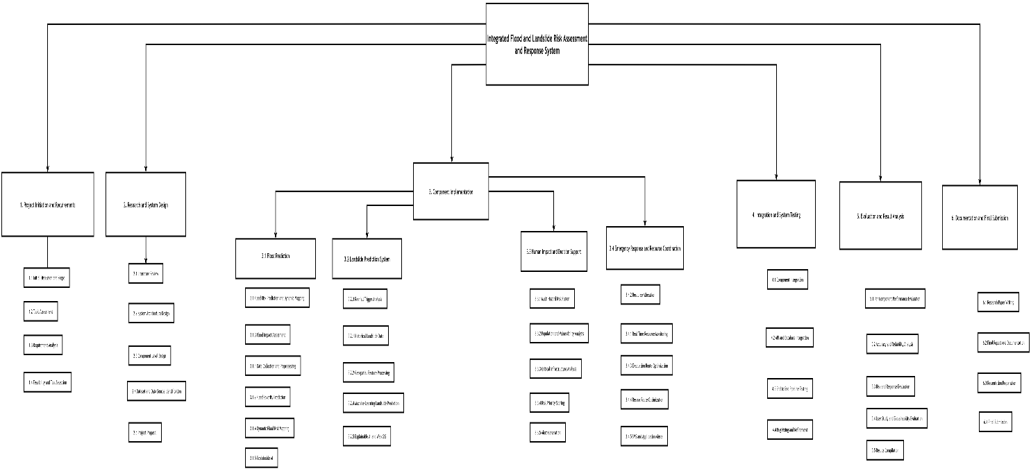

GANTT CHART
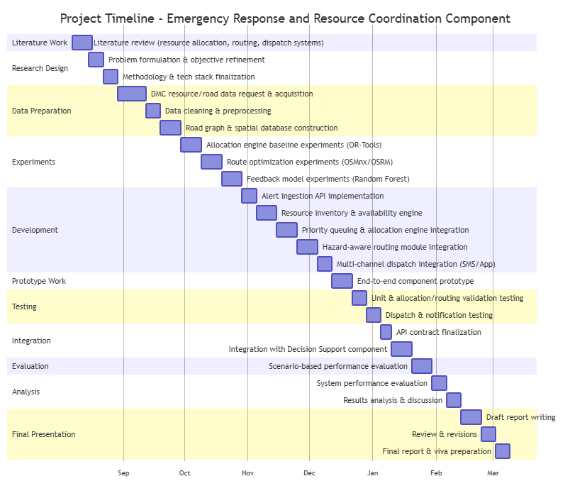

Figure 6.Gaant Chart Of my Component
10. REFERENCES LIST
[1] Al Jazeera, "Sri Lanka floods leave 600,000 people displaced," May 2017. [Online]. Available: https://www.aljazeera.com/news/2017/05/sri-lanka-floods-leave-600000-people-displaced-170531132021197.html
[2] UN Office for the Coordination of Humanitarian Affairs (OCHA) and UN Resident Coordinator's Office (RCO), "Cyclone Ditwah – situation report (23 January 2026)," United Nations Sri Lanka, Colombo, Sri Lanka, Jan. 2026. [Online]. Available: https://srilanka.un.org/en/308868-cyclone-ditwah-situation-report-23-january-2026
[3] P. Lanerolle, S. Rathnayaka, H. Rupasinghe, S. Madhushanka, U. Samarakoon, and D. Kasthurirathne, "Donate.lk: A smart donation handling system," in Proc. 2018 Nat. Inf. Technol. Conf. (NITC), Colombo, Sri Lanka, 2018, pp. 1–7, doi: 10.1109/NITC.2018.8550072.
[4] S. Aththanayake et al., "ResQConnect: Agentic AI for human-centered disaster response systems," in Proc. SLAAI Int. Conf. Artif. Intell. (SLAAI-ICAI), Sri Lanka, 2025.
[5] 1990 Suwa Seriya, "Ambulance fleet and district station data," 1990 Suwa Seriya Foundation, Sri Lanka. [Online]. Available: https://www.1990.lk
[6] Geofabrik GmbH, "OpenStreetMap data extracts – Sri Lanka," Geofabrik. [Online]. Available: https://download.geofabrik.de/asia/sri-lanka.html
[7] [Google, "OR-Tools: Operations research tools," Google Developers. [Online]. Available: https://developers.google.com/optimization
[8] G. Boeing, "OSMnx: New methods for acquiring, constructing, analyzing, and visualizing complex street networks," Comput. Environ. Urban Syst., vol. 65, pp. 126–139, 2017.
[9] S. Aththanayake et al., "ResQConnect: Agentic AI for human-centered disaster response systems," in Proc. SLAAI Int. Conf. Artif. Intell. (SLAAI-ICAI), Sri Lanka, 2025.
[10] draw.io, “draw.io - Diagrams for Everyone, Everywhere,” draw.io. https://drawio-app.com (accessed Sept. 15, 2026).
[11] DesInventar Sri Lanka, "Event-level disaster records (fatalities, displaced, duration)," UNDRR DesInventar Sendai. [Online]. Available: https://www.desinventar.net/DesInventar/profiletab.jsp?countrycode=lka
[12] V. Muralidharan, M. Dharani Dharan, S. Kannan, K. Potrivel, S. Saran, and A. Jenifer, "Disaster response and emergency management system," Int. Sci. J. Eng. Manage. (ISJEM), vol. 5, no. 7, Jul. 2026, doi: 10.55041/ISJEM08138.

APPENDICES

Appendix 1
Appendix A: Prototype Evidence
Integrated Flood and Landslide Risk Assessment and Response System for Sri Lanka Live demo: https://sri-lanka-3-d-map.vercel.app/
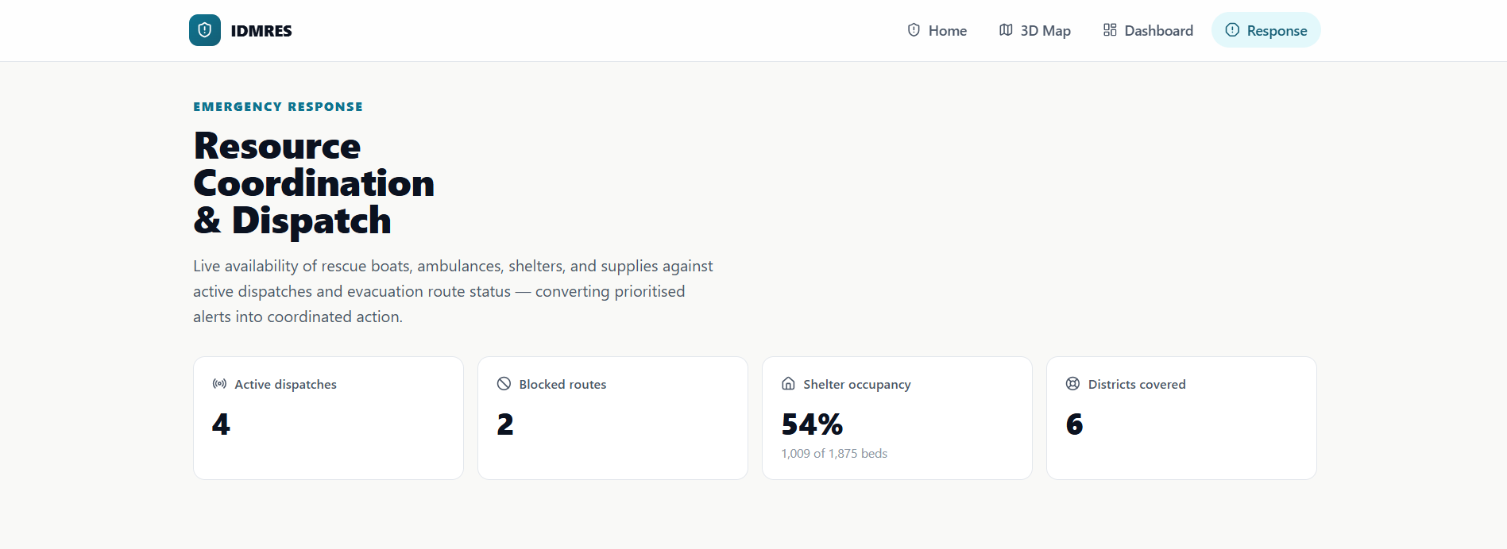

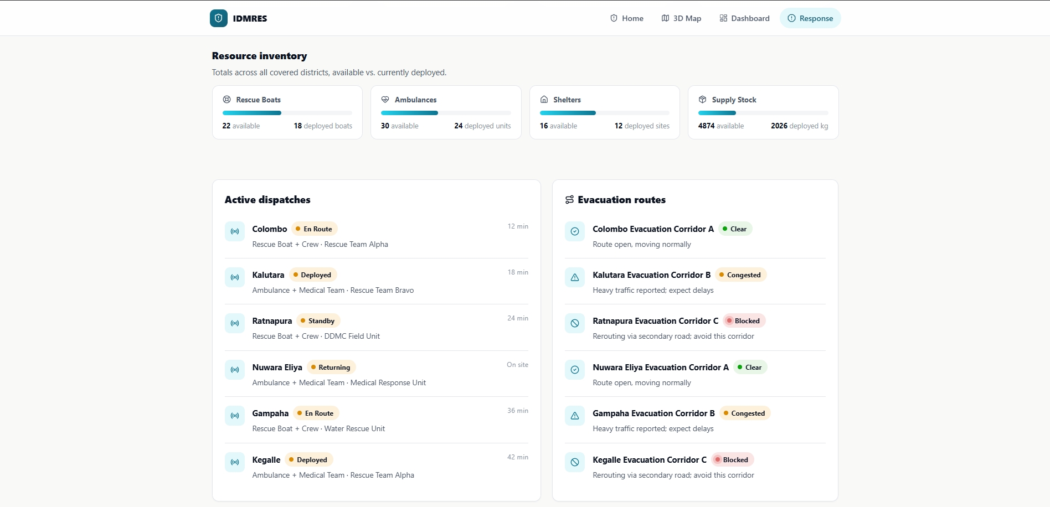

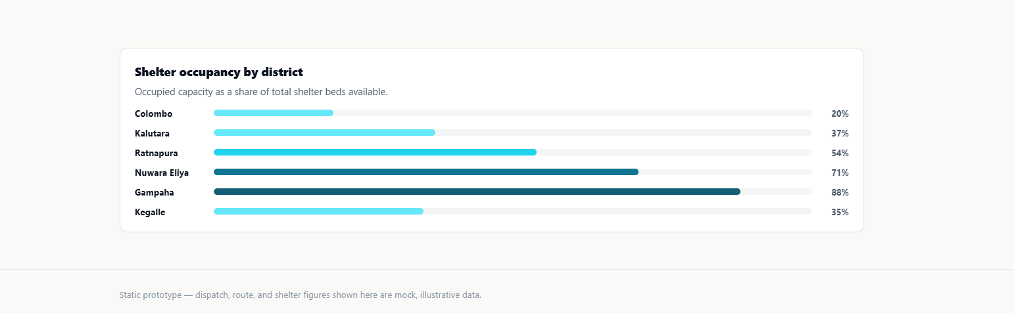

Appendix C: Preliminary Research Notes (Requirements Elicitation & Research Design)
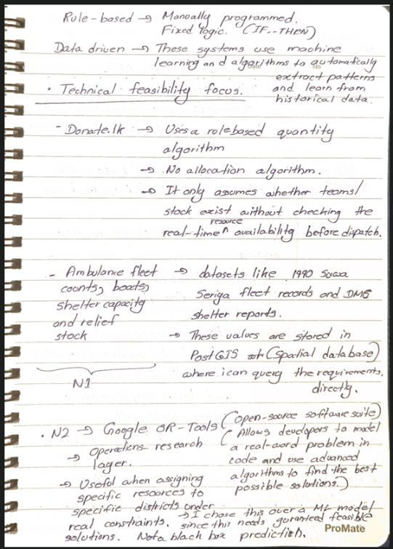
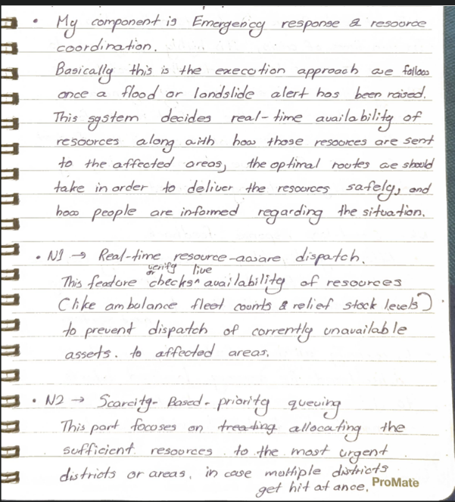
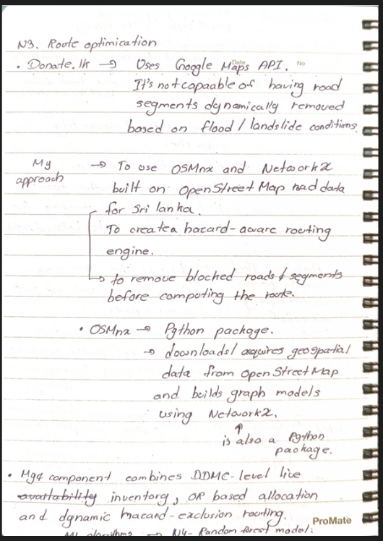
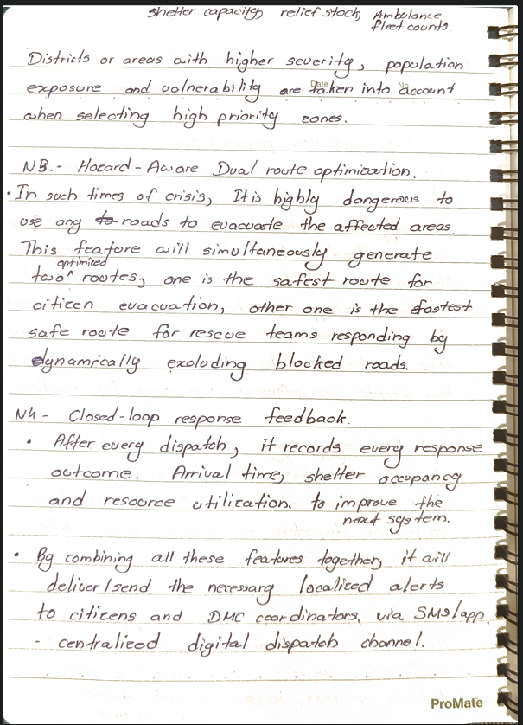

Appendix 2 - Mandatory Proposal Evidence and Decision Log
Each student should maintain the following log throughout proposal development.

Date | Claim / Problem | Evidence Collected | Alternatives Considered | Decision Made | Supervisor Discussion
Aug 21, 2026 | Evaluating Panel Feedback: Clarifying the responsibility boundary between the Emergency Response component and other components | Proposal presentation defense before the Evaluating Panel. The panel approved the overall direction but flagged that resource-allocation and alert-prioritization responsibilities appeared to overlap between the two components. | Formally separate the two via a defined API contract, so each component owns a distinct stage of the pipeline (prioritization vs. action). | Adopt a REST API contract boundary: the Decision Support component owns hazard scoring and alert prioritization; this component owns everything from resource allocation onward (availability check, allocation, routing, dispatch, feedback). No shared internal logic between the two. | The panel granted conditional approval to proceed, on the condition that the two components' boundaries be structurally enforced (not just described) before implementation begins.
Sep 04,2026 | Technical Design Validation: Choosing between a custom allocation heuristic and an established optimization solver for resource-to-district assignment. | Comparative review of allocation approaches used in similar systems (DREMS's greedy + 2-opt heuristic) versus operations-research literature on constrained assignment problems. | Implement a custom greedy/heuristic allocation algorithm, like DREMS. Use Google OR-Tools' constraint solver to declaratively define allocation constraints (capacity, resource-type matching, hazard exclusion). | Adopt OR-Tools for the allocation engine, since a maintained constraint solver guarantees feasible, near-optimal solutions and can absorb new constraints without rewriting core logic a better fit than a hand-built heuristic given project timeline constraint. | Supervisor agreed that using an established solver was more defensible for a final-year project than developing and validating a custom optimization heuristic from scratch.

Appendix 3 - AI Use Disclosure
Students should disclose any use of generative AI tools during proposal preparation.

AI Tool | Purpose of Use | What Was Generated/Assisted | How Output Was Verified | Final Student Contribution
Claude AI | Helped me think through the report structure and reword rough drafts into clearer academic language. | Suggested restructuring for a few sections and offered alternative phrasing for technical explanations. | Every fact, citation, and technical claim was checked against the original sources before being kept in the report. | Wrote and finalized all content; AI suggestions were only used where they matched what I had already researched
Gemini | Used occasionally to clarify unfamiliar technical terms while writing. | Gave short explanations of a few concepts I wasn't fully familiar with. | Compared explanations with lecture material and reliable references before using them anywhere in the report. | Used Gemini's explanations only to cross-check my understanding before applying the concepts in the report.

